YRead? Titles
3rd – 6th Grade
Cover | Title | Author
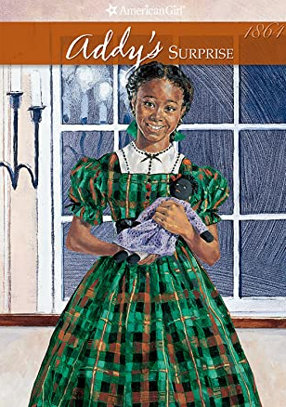 | Addy’s Surprise | Connie Porter
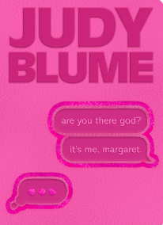 | Are You There God? It’s Me, Margaret | Judy Blume
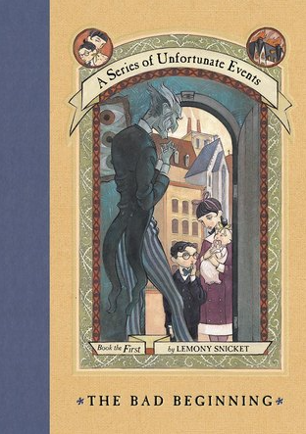 | The Bad Beginning | Lemony Snicket
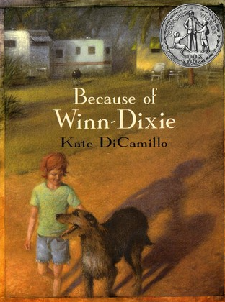 | Because of Winn-Dixie | Kate DiCamillo
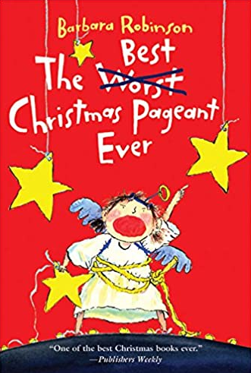 | The Best Christmas Pageant Ever | Barbara Robinson
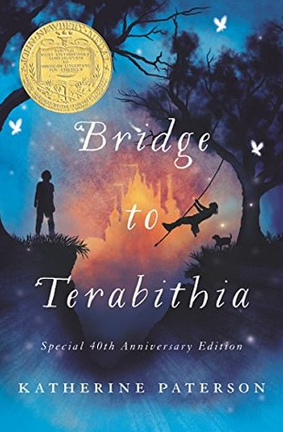 | Bridge to Terabithia | Katherine Paterson
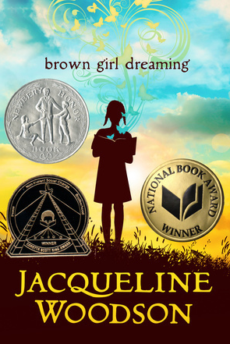 | Brown Girl Dreaming | Jacqueline Woodson
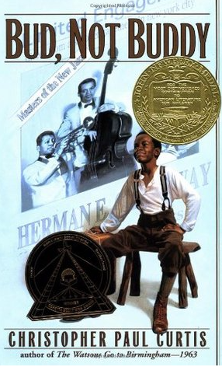 | Bud, Not Buddy | Christopher Paul Curtis
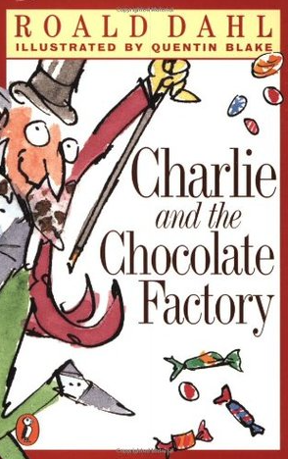 | Charlie and the Chocolate Factory | Roald Dahl
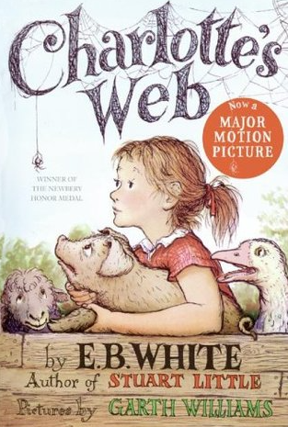 | Charlotte’s Web | E.B. White
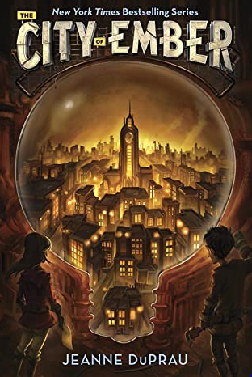 | City of Ember | Jeanne DuPrau
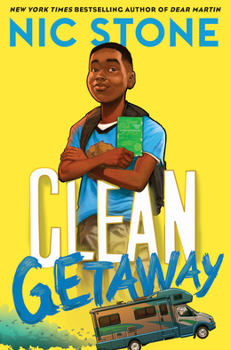 | Clean Getaway | Nic Stone
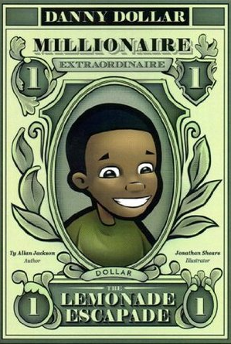 | Danny Dollar Millionaire Extraordinaire - The Lemonade Escapade | Ty Jackson
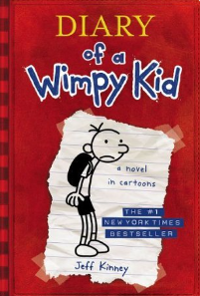 | Diary of a Wimpy Kid | Jeff Kinney
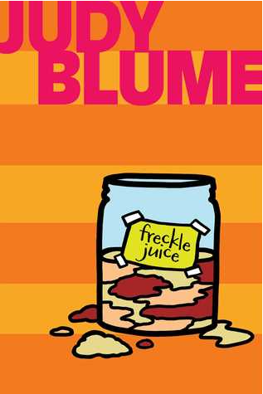 | Freckle Juice | Judy Blume
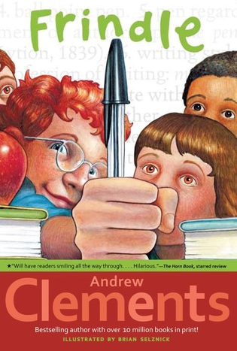 | Frindle | Andrew Clements
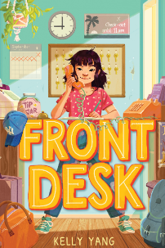 | Front Desk | Kelly Yang
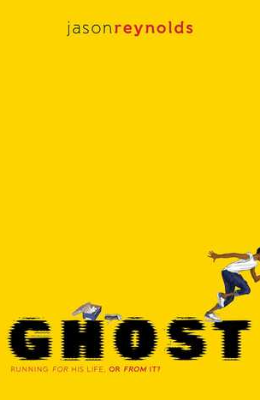 | Ghost | Jason Reynolds
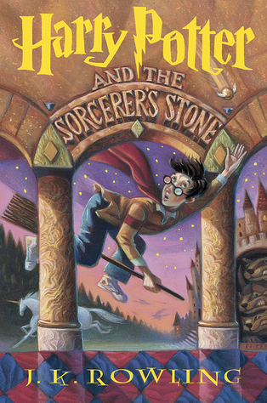 | Harry Potter and the Sorcerer’s Stone | J.K. Rowling
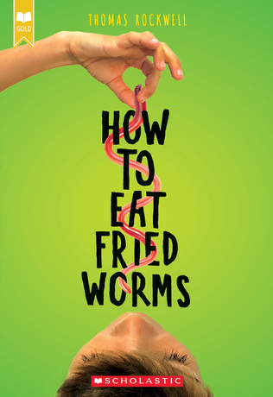 | How to Eat Fried Worms | Thomas Rockwell
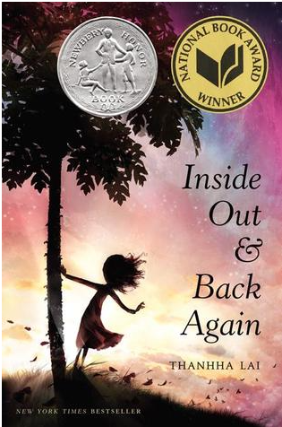 | Inside Out and Back Again | Thanhha Lai
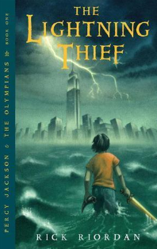 | The Lightning Thief | Rick Riordan
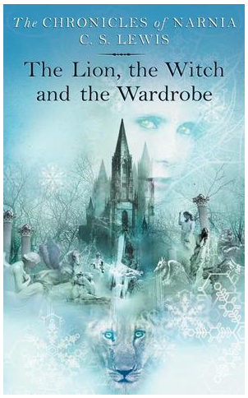 | The Lion, the Witch and the Wardrobe | C.S. Lewis
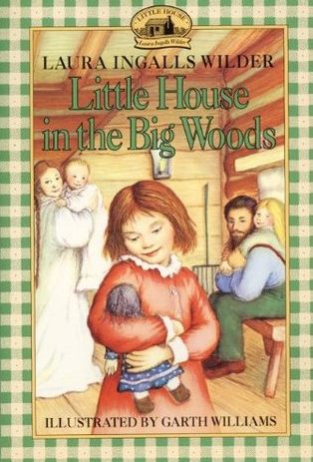 | Little House in the Big Woods | Laura Ingalls Wilder
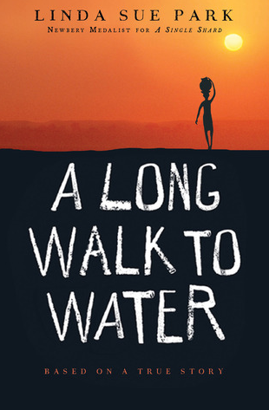 | A Long Walk to Water | Linda Sue Park
 | Love That Dog | Sharon Creech
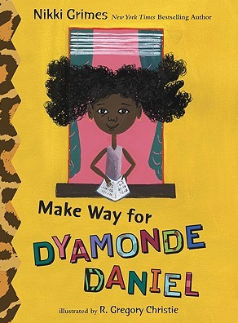 | Make Way for Dyamonde Daniel | Nikki Grimes
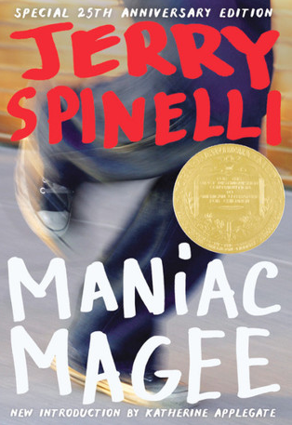 | Maniac Magee | Jerry Spinelli
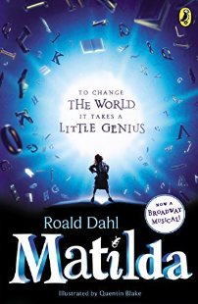 | Matilda | Roald Dahl
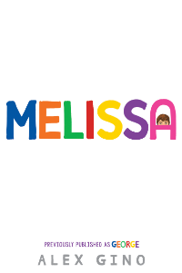 | Melissa | Alex Gino
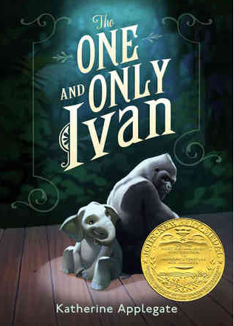 | The One and Only Ivan | Katherine Applegate
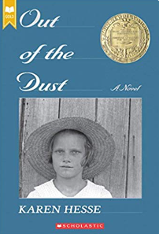 | Out of the Dust | Karen Hesse
 | Patient Zero (Revised Edition): Solving the Mysteries of Deadly Epidemics | Marilee Peters
 | Roll of Thunder, Hear My Cry | Mildred Taylor
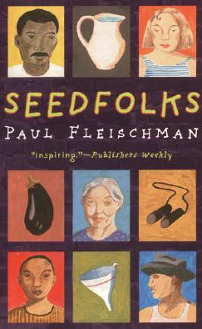 | Seedfolks | Paul Fleischman
 | Shiloh | Phyllis Reynolds Naylor
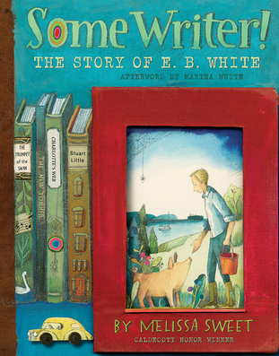 | Some Writer!: The Story of E.B. White | Melissa Sweet
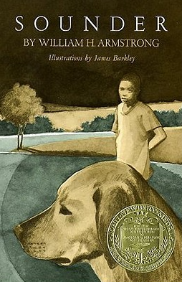 | Sounder | William Armstrong
 | Stamped (for Kids): Racism, Antiracism, and You | Jason Reynolds
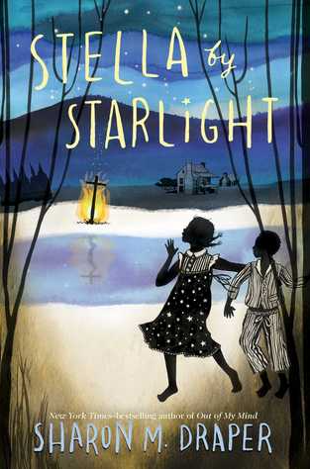 | Stella By Starlight | Sharon M. Draper
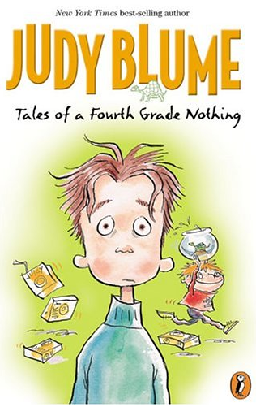 | Tales of a Fourth Grade Nothing | Judy Blume
 | Tangerine | Edward Bloor
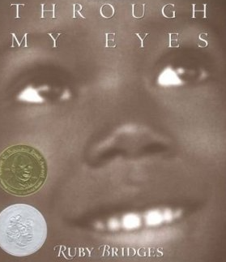 | Through My Eyes | Ruby Bridges
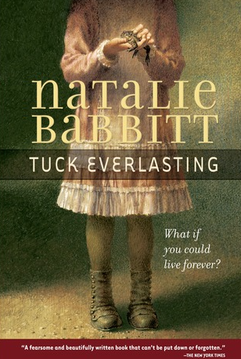 | Tuck Everlasting | Natalie Babbitt
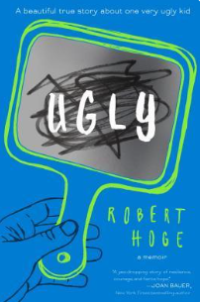 | Ugly | Robert Hoge
 | Unspeakable: The Tulsa Race Massacre | Carole Boston Weatherford
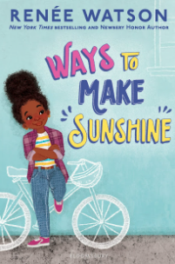 | Ways to Make Sunshine | Renee Watson
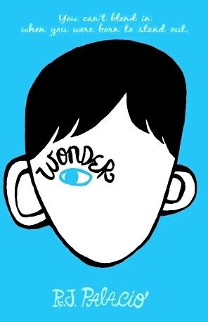 | Wonder | R.J. Palacio

